The Power of Christ’s Resurrection,
Lesson 8Adult Bible Study Guide, 2026 3Q, "First and Second Corinthians"
 The Teacher's Notes — August 15, 2026
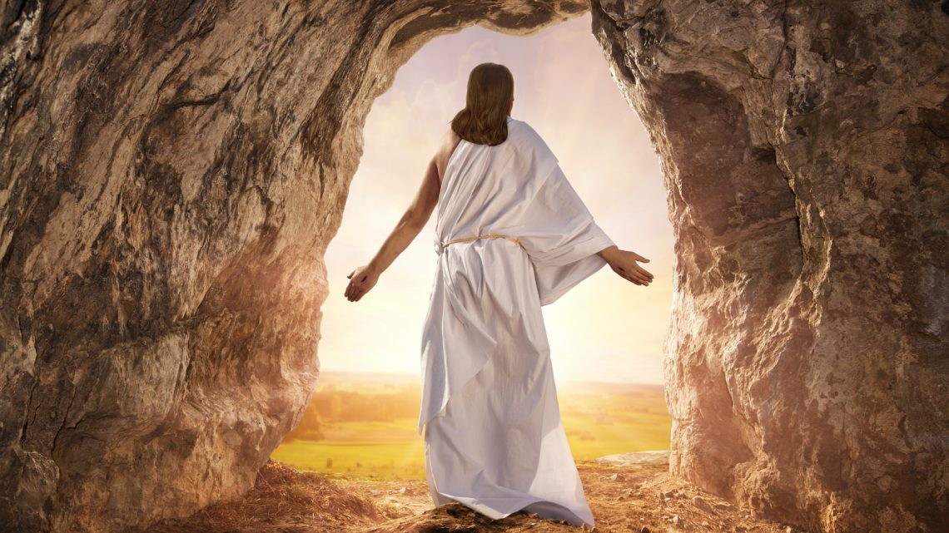
Sabbath School Lesson for August 15-21, 2026
Introduction of Lesson 8, The Power of Christ’s Resurrection
Memory Text: “And if Christ is not risen, then our preaching is empty and your faith is also empty…And if Christ is not risen, your faith is futile; you are still in your sins!” 1 Corinthians 15:14-17 NKJV
Paul left nothing of major importance out of his epistle to the Corinthians. First, he made the case that they must use their spiritual gifts wisely, making sure their service was motivated by love. But, as he emphasized in chapter fifteen, neither of these precautions would matter if the subject of their preaching was not based on the truth about Christ’s death and resurrection.
The whole story of salvation would fall flat and be useless, if they were not given reason to believe they would someday have victory over sin (known as “dying to sin”), and then be resurrected to a glorious future with God in heaven in bodies that would never perish or grow old.
Christ’s miraculous resurrection gives us the faith and hope we need so we can have this victory. Jesus was seen by dozens of eyewitnesses, many who actually felt and touched His transformed, heavenly body. This encourages us to believe in the glorious resurrection of our actual, physical bodies, promised to believers at the first resurrection when He returns.
This week, we’ll explore…
- Sunday: Proclaiming the Resurrection of Christ
- Monday; The Risen Christ, Our Only Hope!
- Tuesday: Christ, the Firstfruits
- Wednesday: The Resurrected Body
- Thursday: Final Victory Over Death
Sunday: Proclaiming the Resurrection of Christ
Paul’ summary at the beginning of chapter fifteen, verses 1-8, relied on two groups of believers to verify what he taught about Christ’s resurrection. He pointed out the many passages in the Old Testament that promised a resurrection of the Messiah. This would, of course, appeal to his Jewish friends, familiar with those Scriptures.
To others living in Corinth, Paul merely suggested they listen to the many eyewitnesses of the events–disciples and apostles, many of whom were still living at the time.
Paul, because of his miraculous vision of Christ on the road to Damascus, included himself as a witness. One has to be impressed by his total transformation, from someone persecuting Christians to one who devoted his whole life to supporting the movement.
Many of those witnesses, including Paul, were willing to lose their lives in order to preach about Christ’s resurrection. And most of them did pay such a price. One must question why so many of them would endanger themselves and their families over this unpopular message if they did not know it to be true.
Verses for reflection and discussion:
1 Corinthians 15:1-4, Psalm 16:10, and Hosea 6:2
- Who would most likely have recognized Paul’s mention of the resurrection in the Old Testament?
1 Corinthians 15:5-8
- Who would these 500 disciples have included?
- Why does the number of 500 disciples sound like a reasonable estimate?
Monday: The Risen Christ, Our Only Hope!
There was indeed something special in Paul’s message of salvation. For the Greeks and much of the ancient pagans, it was believed that we consist of body and soul together, but at death the soul continues to live, soaring off to a place where souls of the dead supposedly go. Therefore, belief in a resurrection of our physical bodies was a new concept.
If Christ is not powerful enough to raise Himself up from the dead and ascend to heaven, we would also have less reason to believe He has the power to save us from our sins and transform our characters.
With so many witnesses to verify Jesus’ miraculous escape from death, witnesses who risked their lives to tell of the experience, we can be confident that our hope for salvation is well-placed in our risen Lord and Savior, Jesus Christ.
Verses for reflection and discussion:
1 Corinthians 15:9-11
- Why did Paul consider himself a reliable witness of Christ’s resurrection?
1 Corinthians 15:12-19
- How important is it that we believe that we, too, will someday be raised to life?
- What difference does this hope in a future after death have in how we live our lives now?
Tuesday: Christ, the Firstfruits
The Feast of Firstfruits in the Old Testament pointed clearly to Christ being the firstfruits of those who have died, or as expressed in most translations, those who have “fallen asleep”. Paul didn’t hesitate in calling Jesus the firstfruits of those who will be resurrected (1 Corinthians 15:20).
Besides showing their thankfulness to God by giving the first and best samples of their fields and flocks, the firstfruit offerings of the Old Testament were an indication of their trust in God that He would supply their needs that year with a bountiful harvest to follow. In the same way, we can trust that God will someday reap a bountiful harvest of righteous men and women when Jesus returns to earth, when the “dead will be raised incorruptible” (1 Corinthians 15:52).
There has been some confusion and debate about “the baptism of the dead” mentioned in 1 Corinthians 15:29. In context, Paul may have been referring to our desire to be baptized so we will be able to be reunited with those who have died before us. One of the main ideas Paul wanted his readers to understand was that baptism, dying to sin, needs to include a resurrection into a new life.
Verses for reflection and discussion:
1 Corinthians 15:20-22
- Explain what Paul meant by this comparison of Adam and Christ.
1 Corinthians 15:23-28
- What is the last enemy Jesus will destroy (v. 26)?
- How does the universe know that Jesus reigns over all?
1 Corinthians 15:29-34
- In what way does Paul (and all of us) die daily?
- What must we do about this problem of sin?
Wednesday: The Resurrected Body
Paul knew there was a natural interest in what our resurrected bodies will be like, so he presented several analogies to help us understand the concept.
- It’s like the transformation of a seed that is planted and grows into various kinds of plants, all of them different in appearance than the tiny seed in the ground. Therefore, our resurrected bodies will be different than they were on earth.
- The different kinds of bodies here on earth–bodies of humans, animals, fish, and birds–are all appropriate to the environment in which they live. In the same way, our present, earthly bodies will be different after the resurrection, in order to fit into the heavenly realms beyond this world.
- Just as there are differences between the sun, moon, and stars, so will our resurrected, heavenly bodies differ from each other. We won’t all be the same in heaven, just as we aren’t all the same here on earth.
Paul also listed four different ways our heavenly bodies will differ from our earthly ones. Now they are terrestrial (tied to this earth), perishable (subject to death), weak, and natural. But then, they shall be heavenly, imperishable, powerful, and spiritual. We will not have the same decaying, weak bodies we were before the resurrection. Praise God!
Verses for reflection and discussion:
1 Corinthians 15:35-41
- How does Paul explain how the resurrection will affect our earthly bodies?
1 Corinthians 15:42-53
- Why do people with physical limitations feel uplifted and encouraged by Paul’s words about the resurrection?
- Why are all of us thankful for Paul’s description of our resurrected bodies?
Thursday: Final Victory Over Death
Paul understood that “flesh and blood”, in other words our fallen humanity, will be changed at the resurrection (1 Corinthians 15:50). The perishable will be raised imperishable. The mortal body will put on immortality.
Coming after our justification and sanctification, this final stage of our salvation is known as glorification, because at that time, we will have an immortal, glorified body.
The final victory over death will be won. And all this will happen “in a moment, in the twinkling of an eye, at the last trump” (1 Corinthians 15:52), when Jesus comes to call the righteous dead from their graves (1 Thessalonians 4:16, 17). Evidently, time passes quickly when you’re having a good sleep.
Verses for reflection and discussion:
1 Corinthians 15:54-58
- What does our final victory over death look like?
- What are you personally looking forward to at the resurrection?
Friday: Final Thoughts
The raising of Lazarus represented the resurrection of the righteous dead. But he was raised from the tomb to continue life in his previous, perishable body. The later resurrection of Jesus, on the other hand, showed us that God has the power to give us an immortal body as well. It was the crowning act of the Messiah, showing us His divine power to give life, and why we can trust our lives so fully to Him.
One can understand why Christ’s resurrection was pivotal to Paul’s message of salvation. Through this powerful, divine Messiah, we, too, can have eternal life with God.
The resurrection that happens at the Second Coming, as Paul described it in both 1 Corinthians 15 and 1 Thessalonians 4, would make no sense, if, as many Christians now believe, our spirits are already in heaven with the Lord. Paul and all the prophets, even Jesus, understood that death is a sleep. Those who die are described many times in Scripture as having fallen asleep.
Next Week: Love-driven Ministry
To read the Sabbath School Lesson Quarterly and see more resources for its study, go to
https://www.sabbath.school/

