The Prophetic Writings, Lesson 6
Adult Bible Study Guide, 2026 4Q, "The Gift of Prophecy"

The Teacher's Notes — October 31, 2026
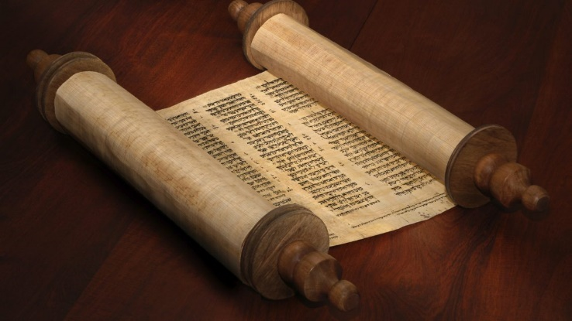
Sabbath School Lesson for October 31-November 6, 2026
Introduction of Lesson 6, The Prophetic Writings
Memory Text: “For whatever things were written before were written for our learning, that we through the patience and comfort of the Scriptures might have hope.” Romans 15:4 NKJV
A lasting, effective way for us to know God better has been the written word of God. Sometimes, God instructed prophets to relay messages to us orally or through dramatized actions, but it’s also good to have the permanent, written record to help us understand God and grow our love for Him.
The Scriptures are a valuable source of learning for the Christian. They give comfort by patiently explaining, in the prophet’s own words, what God has communicated by revelation to His chosen messengers. Our hope is built on the revelations and promises we find in the Holy Bible.
Different writers mean that there are various styles and genres in the Bible to appeal to our individual needs. There we find narratives, history, poetry, sad laments, and letters. There’s something there for everyone, and it’s wise to read and apply as many as we can to our present situation.
This week, we’ll explore:
- Sunday: The Call to Write
- Monday: Literary Genres and Styles
- Tuesday: Literary Assistants
- Wednesday: Literary Sources
- Thursday: Divine Message and Human Imperfections
- Friday: Ellen G. White’s Writings
Sunday: The Call to Write
The Bible reveals that God, at times, called for a prophet to record His messages. Their written words would serve “as a memorial” so people would be reminded of God’s leading in the past. Moses was the first we know of to receive such a call to write (Exodus 17:14). Along with Jeremiah, another major prophet, they each wrote several books of the Bible we have today.
Although the Bible was written under a great many different circumstances, several writers felt called to write at times when it was most feasible and helpful for them. Moses, for example, wrote his five books while in the desert. David wrote several psalms while being hunted down by King Saul, and Daniel, while serving in the foreign governments of Babylon and Medo-Persia.
In the New Testament, we likewise find Paul writing his letters while in prison and John, while he was exiled on the island of Patmos. Each Bible writer felt a divine, urgent call to write God’s words as faithfully as they were able.
Bible verses for reflection and discussion:
Exodus 17:14 and Jeremiah 36:2, 3
- For what reason were Moses and Jeremiah told to write?
Psalm 54:1-7
- How do David’s psalms, written when he was running away from Saul, benefit people even today?
Monday: Literary Genres and Styles
Isaiah 13:1 refers to a message, prophecy, oracle, or pronouncement that was given to Isaiah. Various translations of the Bible use these different words. But the King James Version calls it a “burden”, which may have been a good description. The important messages given to prophets often felt like a burden they were compelled to share with others.
Fortunately, the prophets were allowed to express these “burdens” in various styles that felt comfortable to them. Literary devices such as parallelism, metaphors (symbols), and hyperbole (exaggeration) were used, making the Scriptures appealing for us to read and easier to understand and remember. Jeremiah 2:4-9 even used courtroom imagery, with God as the prosecutor, laying out a case for the judgment He was about to give.
The Bible contains all kinds of writing: history, songs, parables, and letters. Another genre would be apocalyptic writing, as we see with Daniel, Zechariah, and John. These apocalyptic books abound in cosmic themes, rich symbolism, and descriptions of heavenly places and beings.
Verses for reflection and discussion:
Isaiah 13:1
- Have you ever felt like something you had to share was a “burden”? What made it feel that way?
- Why have biblical writers been allowed to use different styles and genres, as they recorded their messages from God? How does that benefit us?
Tuesday: Literary Assistants
Circumstances made it sometimes necessary for prophets to employ assistants to help with their writing. Not everyone has the writing or language skills necessary for such a task. Not surprisingly then, we find evidence of careful editorial work being done for some prophets and apostles, with their assistants even being identified on occasion.
Baruch, one assistant, reveals that the major prophet Jeremiah dictated to him what to write (Jeremiah 36:17, 18). Paul, as he was commending several helpers of the church, didn’t forget Tertius, mentioning him as the one who wrote his letter (Romans 16:22). Bible scholars have questioned the two letters of Peter, because of their differing literary styles. It’s been mostly accepted that Peter, who was fluent only in Aramaic, may have needed help from two different translators to enable him to reach those whose native language was Greek.
The work of literary assistants should not alarm us when we remember that it’s the thoughts of God that count, not the words themselves. God, of course, was behind the thoughts of prophets who wrote the Scriptures, and even the final compilation and preservation of their words.
Verses for reflection and discussion:
Jeremiah 36:17, 18 and Romans 16:22
- What are some of the reasons why literary assistants are needed–both today and in biblical times?
Colossians 4:18 and 2 Thessalonians 3:17
- Why did Paul add this to the end of some of his letters?
- What does this admission tell us about who did the transcribing of his words?
Wednesday: Literary Sources
The authors of the Bible did not hesitate to quote other sources in their recording of God’s messages. Several of them, like Luke, Jude, Paul, Jeremiah, Ezra, and Nehemiah, all quoted or referenced other writings that expressed the messages they were sharing.
Luke, who wrote one of the Gospels about Jesus’ life, was not an eyewitness to any of the events, but knew several of Jesus’ companions and recorded their stories about the Messiah. He definitely gathered and used several information sources to complete his work.
This use of other sources apparently did not distract from God’s authority. God uses every means available to reach us. The ultimate Source was still God. He lovingly allows His messengers to choose what words to use, even if that means borrowing from other sources to do it.
Verses for reflection and discussion:
Luke 1:1-4
- How did Luke, a former Gentile, become so familiar with Christ’s life?
- Why did Luke, a physician, feel it would be beneficial for him to record the life of Jesus, even though he had not witnessed the events himself?
- What makes Luke’s account so valuable?
Jude 14, 15, Acts 17:28, and Titus 1:12
- Why did these writers quote or use other sources?
Thursday: Divine Message and Human Imperfections
God chose imperfect humans to reveal His will. Therefore, we shouldn’t be surprised when the words they wrote about the messages they were given are not entirely perfect either. Paul aptly described it this way: “But we have this treasure (including God’s word) in earthen vessels (humans)…” (2 Corinthians 4:7).
We can therefore expect some discrepancies and mistakes in the Bible. But remember that they are inconsequential errors when it comes to our understanding of what God wants to convey to us. Overall, God’s human messengers wrote about divine truths as faithfully as they were able.
The combination of human and divine was explained this way by Ellen G. White: “The union of the divine and the human, manifest in Christ, exists also in the Bible. The truths revealed are all ‘given by inspiration of God,’ yet they are expressed in the words of men and are adapted to human needs.” Testimonies for the Church, vol. 5, p. 747
Verses for reflection and discussion:
2 Corinthians 4:7
- Why has God chosen to have the prophets write His words in their own language, and not just dictate each word to them?
- How does knowing this affect how you read and understand the Bible?
Friday: Ellen G. White’s Writings
It is evident that the writings of Ellen G. White consisted of many elements used by other prophetic writers. She felt a call to write and counsel the church and individual members, as well as speak publicly of those truths God impressed on her heart–even though they were not all well-received.
She relied on assistants to help with the editorial work involved in publishing her books and articles. And she did not hesitate to use the words of other sources when it added to the message content she was trying to articulate, just as done by many writers of the Bible. She even recommended some of the books she used for that purpose. This humble, 19th-century Christian author recognized her human imperfections. Like all of us, she matured and grew both in her spiritual life and her writing skills during her 87 years on earth.
“In regards to infallibility, I never claimed it; God alone is infallible [not capable of making mistakes].” Selected Messages, book 1, p. 37
The Seventh-day Adventist Church continues to be blessed by her published writings, which have drawn us closer to God and His word in these last days of earth’s history.
Next Week: Now Hear This!
To read the Sabbath School Lesson Quarterly and see more resources for its study, go to
https://www.sabbath.school/

