New Testament Prophets, Lesson 4

Adult Bible Study Guide, 2026 4Q, "The Gift of Prophecy"
:
The Teacher's Notes — October 17, 2026
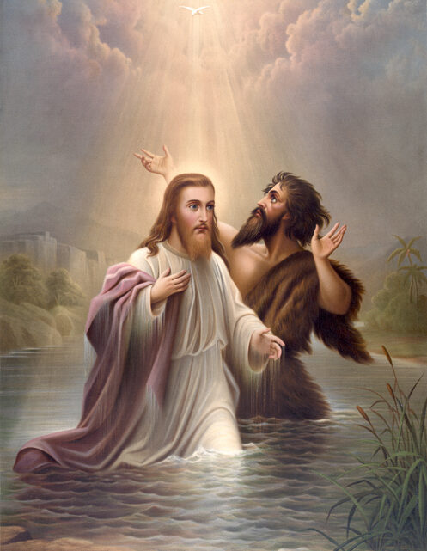

Sabbath School Lesson for October 17-23, 2026

Introduction to Lesson 4, New Testament Prophets
Memory Text: “There are diversities of gifts, but the same Spirit. There are differences of ministries, but the same Lord. And there are diversities of activities, but it is the same God who works all in all.” 1 Corinthians 12:4-6 NKJV
The messages received from prophets in the Old and New Testaments are surprisingly in harmony with each other. All true prophets come from the same Source, the Holy Spirit. There were different purposes for their various ministries, but the same God upheld them all.
Depending on time and circumstance, prophets of God do much to encourage and edify God’s people. Their work provides the foundation of the church.
Old Testament prophets focused on getting ready for the Messiah to come. They were essential in laying the groundwork for prophets in the New Testament to center their attention on the work of Christ, the most consequential, influential Prophet of all. We are now encouraged to get ready for His Second Coming.
This week, we’ll explore:
- Sunday: Jesus as Prophet
- Monday: Apostles and Prophets
- Tuesday: Functions of New Testament Prophets
- Wednesday: Female Prophets and Young Pastoral Associates
- Thursday: False Prophets in the New Testament
- Friday: Keeping Jesus and His Word at the Center

Sunday: Jesus as Prophet
Perhaps you’ve never thought of Jesus as a Prophet, since we mostly think of Him as Creator, Savior, Redeemer, Friend of sinners, and so much more. But, no Prophet was a better spokesperson to represent God the Father, than His own precious Son, the Promised Messiah.
Moses, a respected prophet himself, pointed to a great Prophet who would come after him (Deuteronomy 18:15). New Testament authors quoted this verse and proclaimed that Jesus was the Prophet spoken of by Moses (Acts 3:22 and John 6:14).
Peter, one of Jesus’ close disciples, answered Jesus’ query about who He was by confirming that He was the Christ, or in Hebrew, the Messiah, the Anointed One. Christ, God’s own Son, was designated and consecrated for the most holy task of saving us from sin by dying in our place.
Verses for reflection and discussion:
Deuteronomy 18:15, Acts 3:22, and John 6:14
- How did Jesus fulfill the requirements of someone called to be a prophet?
- In what ways was Moses like Jesus, the Prophet people had always longed for? What things did they have in common?
Matthew 16:13-20 (also found in Mark 8:27-29, and Luke 9:18-20)
- Why do you think Jesus asked the disciples about His identity?
- Why are we not surprised to find Peter as the one who answered Him?
- What was the rock that the church would be built upon?
- Why were the disciples then told not to tell others about His identity?

Monday: Apostles and Prophets
There is some confusion about who apostles and prophets are, what they do, and if there is some difference in them. The Greek word apostolos refers to “messengers” or “ones sent forth”. This would naturally include the original twelve disciples who were sent by God to preach the gospel.
There are others, however. Paul, not one of the twelve disciples, introduced himself as an apostle in many of his epistles. He was indeed divinely called by God in a vision on his way to persecute Christians. This encounter with Christ resulted in Paul having a major role in reaching the Gentile world with the gospel.
We find in the New Testament a helpful analogy for understanding who apostles and prophets are. The church is referred to as a building. Jesus is the Chief Cornerstone of that building, the One on whom the whole structure depends. He is the main One of many apostles and prophets who make up the foundation of the church. All its other members, then, are called “living stones”, and are also vital in making the church a suitable dwelling place for God. See Ephesians 2:20 and 1 Peter 2:4-5.
Verses for reflection and discussion:
Ephesians 2:20 and 3:5
- Why are apostles and prophets mentioned together like this?
1 Peter 2:4, 5
- Who are the “living stones” and what purpose do they serve, compared to those who make up the foundation, the apostles and prophets?

Tuesday: Functions of New Testament Prophets
Several verses in the New Testament describe the valuable functions of God’s messengers. Their task was not merely to predict future events. Like several Old Testament prophets, they were sent, as needed, to provide encouragement, point out inadequacies, and help the church grow in faith and love–all things that edify a church, making it strong enough to ride out the storms of life. They are indeed the foundation we, the living stones, are to build on.
Our world today has little to offer when it comes to things we can trust without hesitation. But when prophets focus on the written word, the Bible, and the Word made flesh, Jesus Christ, we know we have found a message we can trust. One that has a good foundation.
When times of tribulation come, God’s people need the strength and hope that those with the gift of prophecy can supply. Thankfully, God has promised that the special gift of prophecy will continue to bless us, even in the last days. See Acts 2:17, 18.
Verses for reflection and discussion:
1 Corinthians 14:3, Ephesians 4:11-13, and Revelation 22:6
- What is the role of prophets in the New Testament?

Wednesday: Female Prophets and Young Pastoral Associates
God does not withhold His prophetic gifts from women (both young and old) and young pastors. These groups have regretfully been overlooked, now and in the past. But the New Testament shows how they have contributed to the edification of God’s church. Here’s some prominent examples in the Bible:
- Anna–called a prophetess, was an elderly widow, who had a full-time ministry, serving “God with fastings and prayers night and day” Luke 2:36-38
- Philip’s daughters–four of them who were “virgin daughters who prophesied” Acts 21:9
- Timothy–who worked closely with the apostles, and was mentored by them. Paul called him “a true son in the faith” 1 Timothy 1:2
- Titus–Paul gave him important responsibilities and also counseled him to “Let no one despise you” (apparently for being so young). Titus 2:15
Verses for reflection and discussion:
Luke 2:36-38, Acts 21:8-9, 1 Timothy 1:2, 4:12, Titus 1:4, and 2:15
- Why is it important to remember the contributions of these groups of people?
- What other groups might be overlooked in your congregation, and how can you include them more in your church ministries?

Thursday: False Prophets in the New Testament
Jesus not only warned about false prophets in His discourse about end times (Matthew 24:24), but they were even mentioned earlier in His Sermon on the Mount (Matthew 7:15-16). These false messengers might appear harmless, but inwardly they are “ravenous wolves”, He warned. We will know them by their fruits. Do they produce good spiritual fruits like love, peace, joy, kindness, etc., or bad “fruit”, which are just the opposite?
Even supernatural events should not fool us into believing in these questionable prophets. There are powers of darkness in this world, so we must never lose our spiritual focus on the true God, who loves us beyond measure. These supernatural enemies of God easily work through false prophets.
We are given the best weapons to fight “wickedness in the heavenly places” in Ephesians, chapter 6. Our spiritual armor includes, faith, righteousness, and the truth. With prayer, staying grounded in God’s word, and sharing the gospel with others, we are equipped to fight the battle against sin and have positive results.
Verses for reflection and discussion:
Matthew 7:15-16 and 24:23-24
- Why have false prophets always been a problem for God’s people?
- How can we know them for who they are?
Ephesians 6:10-12
- Who is behind false prophets and why are they so dangerous?
Ephesians 6:14-18
- How can we equip ourselves to recognize false prophets?

Friday: Keeping Jesus and His Word at the Center
All God’s prophets have, in their own way, uplifted God’s Son. He has undoubtedly been the center of all their work. We, therefore, expect prophets to uphold Jesus, the Word of God made flesh, and God’s written word, the Holy Scriptures.
Ellen G. White, one prophet in these last days, has been careful to point to Jesus in all her ministry. Her most popular book, Steps to Christ, certainly shows how important He is in our lives and how we can draw closer to Him, the Author and Finisher of our faith.
In addition, she continuously pointed to the Bible as the rule of our faith and practice. She saw her writings as a “lesser light” leading people to the Bible, the “greater light”. Her five-book Conflict of the Ages series help make the Scriptures come alive and make us want to read for ourselves what it says in the Bible.
Next Week: Revelation and Inspiration
To read the Sabbath School Lesson Quarterly and see more resources for its study, go to
https://www.sabbath.school/

