Repentance and Forgiveness, Lesson 10Adult Bible Study Guide, 2026 2Q, "Growing in a Relationship With God"

SHARE ON:
 The Teacher's Notes — May 30, 2026
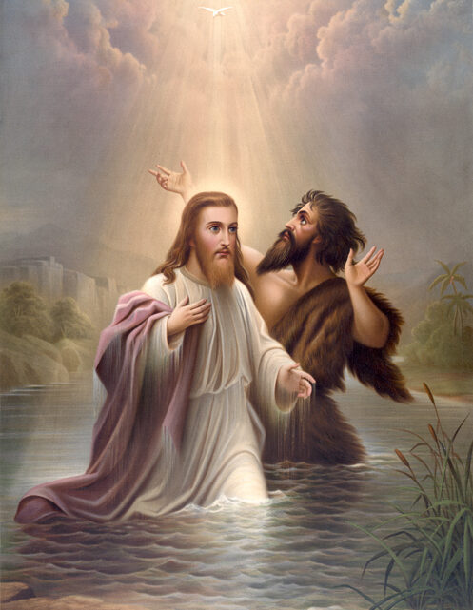
Sabbath School Lesson for May 30-June 5, 2026
Introduction for Lesson 10, Repentance and Forgiveness
Memory Text: “If we confess our sins, He is faithful and just to forgive us our sins and to cleanse us from all unrighteousness.” 1 John 1:9 NKJV
As 1 John 1:9 indicates, our Lord is faithful (being full of lovingkindness), and just (trustworthy enough to deal with us fairly). When we repent of our thoughts and actions that separate us from Him, God’s forgiveness has the power to cleanse us from our unholy behavior.
One of the most dramatic episodes in the story of the Exodus that demonstrates God’s forgiveness occurred when the Hebrews allowed a golden calf to be made and worshipped while Moses was on the mountain receiving the Ten Commandments. A mixed multitude who had joined the Hebrews when they came out of their land of bondage had instigated and participated in this defiling behavior. Even Aaron, the brother of Moses, did not have the strength and courage to deny their demanding threats.
As horrific as this sin was, God offered a way that those who repented would be saved from the inevitable death that came from their despicable behavior. Moses’ interceded for God’s people, just as Christ, the One who has led us out of the bondage of sin, now intercedes for us in the courts of heaven.
This week, we will explore:
- Sunday: The Rush of Life
- Monday: Holy Spirit Promptings
- Tuesday: Real Repentance
- Wednesday: Sufficient Grace
- Thursday: The Most Expensive Robe
Sunday: The Rush of Life
There is nothing wrong with a life full of meaningful activity. Martha showed herself to be an active, hospitable friend of Jesus whenever He came to their house. She busied herself with all the preparations necessary to make His stay warm and inviting. When Jesus arrived in their home, however, Martha found out that she needed to have her daily tasks complete, so she could spend time at the feet of Jesus, along with her sister Mary and brother Lazarus.
Martha’s example helps us understand why the Sabbath is so necessary for us to gain the most out of our relationship with God. We, too, must leave the many worldly activities that prevent us from getting the most out of our weekly visits with Him. The day before Sabbath, the preparation day known as Friday, is the time to wrap up as many duties and activities as possible to make the best use of our precious hours with God.
God is always anxious to remove our filthy rags of unrighteousness and exchange them for the garments of salvation (Isaiah 61:10). What better time than the holy Sabbath day to reflect on how God longs for us be clothed in the full beauty of His holiness.
Verses for reflection and discussion:
Luke 10:38-42
- What can we learn from Martha’s rush of activity, and the choice of her sister Mary?
Isaiah 64:6, 61:10, and Psalm 29:2
- Why do we need to step back from the rush of our busy lives and take time to sit at the feet of Jesus?
Monday: Holy Spirit Promptings
We are given insights about the need to repent from the story of Hosea. This prophet was told by God to marry Gomer, a prostitute. Her continued, adulterous behavior was to be a metaphor, reminding the Israelites of their back-and-forth relationship with God. Every time they turned to idolatry, worshiping other gods, they were wounding God’s heart afresh.
Knowing our tendency to offer fleeting, halfhearted apologies to God, followed by excuses and no real effort to change our ways, God has given the job of convicting us of sin to the Holy Spirit (John 16:8). The Spirit continually speaks to our hearts about the many ways we threaten our relationship with God.
One of the most foolish things we can do is refuse to listen to the Spirit’s promptings and continue sinning against our heavenly Father. Paul referred to this refusal as grieving the Holy Spirit (Ephesians 4:30). It surely brings sadness to God when we don’t fully repent and willfully keep repeating our mistakes, just like Gomer, the adulteress wife of Hosea. God can’t pardon or help us when we aren’t listening to His Holy Spirit. That’s why Jesus called our refusal the “unpardonable sin”.
Verses for reflection and discussion:
John 16:8 and Luke 11:13
- Why is the Holy Spirit needed to convict us of sin?
- In what ways can we show our appreciation of this valuable gift from God?
Hosea 6:1-3
- What was the purpose of the early and latter rains in the agriculture of Israel?
- How does this analogy describe the magnified spiritual workings of God through the Holy Spirit?
- When are these rains to occur spiritually, and for what purpose?
Ephesians 4:30 and Mark 3:28, 29
- How do we grieve the Holy Spirit, and why is it a foolish thing to do?
- Why did Jesus call it the “unpardonable sin”?
Tuesday: Real Repentance
The world encourages us to think and act with independence, to indulge in the things that appeal to us, and to put ourselves ahead of others. This “me first” attitude even applies to nations who neglect to see themselves as part of a more global structure. This so-called nationalism causes people to ignore the suffering and needs of other nations, and results in isolating themselves from the world community.
Repentance from these destructive behaviors involves two steps on our part individually.
- With humility and deep sorrow, we must admit our inadequacies and failures.
- We must personally resolve to abandon our sin, and rely on God to give us strength to clean up the mess we have caused by our willful actions.
Simply put, we repent and God forgives. Thankfully, God gives us ample time to do so, because the Bible tells us that He is “not willing that any should perish” (2 Peter 3:9). When we act in faith and repent fully, God is more than happy to prune us and shape our characters to be more like Him. The fruits we thus produce will help others want the transformation they see in us.
Verses for reflection and discussion:
Acts 3:19
- What’s the difference between repentance and conversion?
2 Peter 3:9 and Revelation 3:19
- How and why is God involved in our repentance?
John 15:2, 8 and Acts 11:18
- How is God glorified by our repentance?
Wednesday: Sufficient Grace
No matter how great our sin, or hopeless our situation has become, God has a remedy. It all comes down to His character of love. God describes Himself as “merciful and gracious, longsuffering, and abounding in goodness and truth” (Exodus 34:6).
This beautiful description of God’s love is found several times throughout the Bible–almost word-for-word in Nehemiah 9:17 and Psalm 103: 8. Paul, therefore, reminded us: “…where sin abounded, grace abounded much more” (Romans 5:20).
Jesus personified the merciful, gracious God we serve. His love for us shone most brightly when He died on a cruel cross in order to redeem us from the clutches of sin. Even in these last days of the Laodicean church era, we see that Jesus is still knocking at our heart’s door, ready to come in to dine and dwell with us (Revelation 3:20). The grace He offers is sufficient for all our needs.
Verses for reflection and discussion:
Exodus 34:4-10
- How important was it for Moses, and for us, to know that God is merciful and just?
Romans 6:23 and Romans 5:8
- Why was it such a blessing that Jesus died for us the way He did? What made His death so special?
Zechariah 3:4 and Revelation 3:20
- What common themes do these verses hold for us?
- What happens when we let Jesus into our heart?
Thursday: The Most Expensive Robe
In Jesus’ parable of the wedding feast, found in Matthew 22:1-14, we rejoice at first that so many were finally found to come to the wedding feast. But it was disheartening when one of the invited guests did not wear the expensive wedding garment he had been given for the event. It was required that he be removed bodily from the festivities.
Revelation 19:7, 8 speaks of another wedding feast. The wedding of the Lamb and his bride, symbolizing Jesus and the church. We are told that the bride is “arrayed in fine linen, clean and bright”, which are declared to be “the righteous acts of the saints”. The most expensive piece of clothing at a wedding is often the bridal gown. This helps us appreciate the merciful, loving deeds of God’s people, knowing that they reflect the loving, compassionate God they serve.
Instead of covering ourselves with manmade fabrics of self-righteousness, like Adam and Eve did with fig leaves, we must allow God to clothe us with animal skins that represent the sacrificial Lamb of God’s own dear Son. Only then can we shine as clean, bright lights in our sin-darkened world.
Verses for reflection and discussion:
Matthew 22:1-14
- What was the main message Jesus wanted to convey with this story?
- What do you personally feel drawn to when you hear the parable?
Revelation 19:7, 8 and Ephesians 5:27
- What makes God’s bride (church) sinless and holy?
- Why are the things we do so important?
Friday: Final Thoughts
God wisely chose to use agricultural metaphors to describe His vital truths, including our need for forgiveness and repentance. All cultures across the centuries can identify with concepts that are presented in terms of everyday farming and gardening. Hosea 10:12 is a familiar example:
“Sow for yourselves righteousness, Reap in mercy; break up your fallow ground, for it is time to seek the Lord, till He comes and rains righteousness on you.” NKJV
The rain (representing the Holy Spirit’s ability to make us righteous) softens the hard soil of our hearts, causing us to turn our heads toward the sun and grow straight and tall, bearing fruits of righteousness that bless those on the earth. What a sacred opportunity we have as we steadily grow closer to our Creator God and His heavenly kingdom through our repentance and His forgiveness..
Next Week: Setbacks
To read the Sabbath School Lesson Quarterly and see more resources for its study, go to
https://www.sabbath.school/

