The Role of the Bible, Lesson 4
Adult Bible Study Guide, 2026 2Q,, "Growing in a Relationship with God"

 The Teacher's Notes — April 18, 2026
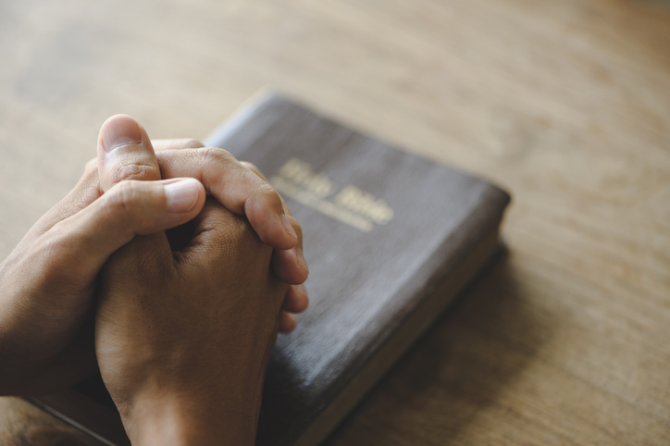
Sabbath School Lesson for April 18-24, 2026
Introduction of Lesson 4, The Role of the Bible
Memory Text: “For the word of God is living and powerful, and sharper than any two-edged sword, piercing even to the division of soul and spirit, and of joints and marrow, and is a discerner of the thoughts and intents of the heart.” Hebrews 4:12 NKJV
Sometimes we humans employ the Bible as a weapon, using it without mercy to win an argument or disarm an offending critic. But the writer of Hebrews had a different kind of weapon in mind. He saw it as a living, powerful two-edged sword, capable of reaching and transforming the deep-seated thoughts and intents of the reader. This holier purpose, in God’s hands, makes it a weapon that encourages, challenges, and guides us to our heavenly home.
The Bible provides us with an accurate picture of God. He is both the Creator of the universe and someone who desires intimate contact with those He created. Quality time spent with God, communicating with Him by praying and reading His word, is never wasted. It arms us to go out and conquer any hardship Satan sends our way to derail that close relationship with God.
When used properly, the Bible, the oldest, most published book available to mankind, becomes a source of hope that can be found nowhere else. When we humbly obey its counsel, nothing is the same in our lives. God’s word gives us a reality check for our pride and helps us know and understand the truth about God’s character.
This week, we will explore…
- Sunday: The Most Powerful Weapon
- Monday: Scripture, the Authority
- Tuesday: Bible Truth
- Wednesday: Bible Claims
- Thursday: State of the Heart
Sunday: The Most Powerful Weapon
Satan’s efforts to block the time we spend with God reveal the level of benefit we gain from prayer and Bible study. God’s enemy uses everything in his arsenal to see that we are too tired, apathetic, busy, or doubtful to take up a deep study of God’s word. He knows how it feeds our soul and makes us willing, obedient servants of our heavenly Father.
It was the word of God that spoke the world into existence (Psalm 33:6), that gives us strength to overcome temptation (Matthew 4:3, 4), and will someday raise the dead to their eternal reward (John 11:41-43). We learn from the Bible how constant and compassionate God is toward all His created beings, and how we can enjoy His companionship to the fullest by knowing Him through the Holy Scriptures.
The study of God’s word equips us to fight Satan by improving our relationships, both with God and with each other. Choosing each day to communicate with God and with our loved ones is a known way to grow and improve our connection with them. Bible study enhances that communication with God.
Verses for reflection and discussion:
Ephesians 6:17, 18
- In what way is the Bible a sword, and how is it, along with prayer, best used to defeat our enemies?
Psalm 33:6, Matthew 4:3, 4, and John 11:41-43
- What does the word of God do that affects each of our lives?
- How has the study of the Bible benefited your life?
Lamentations 3:22, 23
- Why is daily study of the word important?
Monday: Scripture, the Authority
Although human reasoning is limited and capable of error, God does not expect us to ignore our minds when it comes to the study of His word. After all, He tells us to love Him with all our heart, mind, and soul (Matthew 22:37). Every part of our being must be engaged with the task of communicating with God through Bible study and prayer. No haphazard, surface reading, or hasty prayer spoken on the way out the door in the morning, will get us as close to God as He desires.
Taking the Bible as a whole is vital in understanding it in part. We can trust that, with prayer, God will reveal what we need to know when we need to know it. We must persist in searching the Scriptures thoroughly, recognizing its inspired and authoritative content, designed to uplift and guide us in our Christian walk.
Paul gave wise counsel to Timothy, a young pastor. It included a good description of the Scriptures (still just the Old Testament for them), and is one we can all benefit from. 2 Timothy 3:15-17 confirms that God inspired the prophets to write what they did. These writings are profitable for understanding the truth about God and instructing us in how to live righteously.
Verses for reflection and discussion:
2 Timothy 3:15-17
- What is the purpose of Bible study?
- How do you feel more equipped after delving into God’s word? What does it inspire you to do?
Isaiah 55:9 and Matthew 22:37
- What limitations does our mind have when it comes to the study of the Bible?
- How can we overcome these challenges or limitations?
Tuesday: Bible Truth
Jesus answered Pilate’s question “What is truth?”, when He earlier told His disciples: “I am the way, the truth, and the life” (John 14:6). Jesus is therefore the truth. In praying for His disciples to be sanctified, Jesus declared, “Your word is truth” (John 17:17). So, what is truth? Is it: Jesus or God’s word?
John’s gospel account solves this dilemma by confirming that the Word became flesh and dwelt among us (John 1:14). So, the answer is both, because Jesus is the Word and He is also the truth. They are one and the same. This becomes easier to accept when we remember that we, too, can be both a son, husband, and father–or daughter, wife, and mother. Jesus, therefore, can easily be the way, the truth, and the life. He is whatever we need Him to be, all at the same time.
As we know, Jesus does not change (Hebrews 13:8). Therefore, God’s truth can not change. Our understanding of it may shift and grow, but His word stands firm, providing us with a solid foundation on which to build our faith in God. We should never stop asking ourselves Pilate’s question: What is truth?
Verses for reflection and discussion:
John 14:6 and John 17:17
- How can Jesus be both the Word and the truth?
Proverbs 30:5,6 and Psalm 12:6
- Why should we not add to God’s word?
1 Thessalonians 2:13, Ephesians 1:13, and Romans 10:17
- Why is it important to believe what we are reading is the truth?
- How can the word itself convince us of truth?
Wednesday: Bible Claims
We find in the Bible many high claims about itself. Isaiah claimed that God’s word always accomplishes what it’s supposed to (Isaiah 55:11). It won’t come back to us void, or wasted.
The psalmist treasured God’s word so much, he hid it in his heart (Psalm 119:11). Later in the same psalm (v. 50), we discover God’s word gave him life, comforting him in affliction. It’s worth memorizing Scripture, saving it in our minds for any future need. The repetition this requires opens up meanings and understandings that we may have previously missed.
Just as food sustains and gives us life, so does the Bible. Peter called it the pure milk of newborns (1 Peter 2:2), and Jesus confirmed in Matthew 4:4 that we need His word more than we need bread. The prophet Jeremiah symbolically “ate” the word of God–it was that important to him (Jeremiah 15:16). He “hungered and thirsted” for the righteousness it taught him. And Jesus told us that all who do the same will satisfy their hunger (Matthew 5:6).
Verses for reflection and discussion:
Psalm 119:11, 50 and Job 22:22
- What are some of the claims about God’s word in this psalm?
- What’s the difference in reading and hiding, or establishing God’s word in your heart?
- What benefits have you personally felt from reading Scripture, and even memorizing it?
Isaiah 55:11 and Jeremiah 15:16
- When was the last time you felt like “gobbling up” the Bible–that you just couldn’t get enough of it?
- Have you ever felt like studying your Bible was a waste of time, and how can that be turned around for you?
Thursday: State of the Heart
Having the right attitude and approach makes all the difference in how much we are blessed by reading God’s word. It’s important for our hearts to be prepared from the start, if we are to gain the most from reading and studying the Bible.
With humility and faith, we must be spiritually open-minded, so the Holy Spirit can impress upon our minds what we need to understand from the Scriptures. Even if we haven’t expelled all the pride and unbelief from our hearts as we begin to study, we must have some measure of faith, even as big as a mustard seed–and enough humility to make us open to changing our preconceived ideas.
Of course, asking for the Holy Spirit’s help is important. But even if we fail to do that initially, the desire for the Holy Spirit’s help often increases if we are sincere in our desire to know from God what wisdom He has for us and how we can better serve Him.
Verses for reflection and discussion:
1 Corinthians 2:14 and 1 Thessalonians 2:13
- Why are both the Holy Spirit and some measure of belief necessary for profitable Bible study?
2 Timothy 3:15
- How does knowing Scriptures as a child help when we study it as an adult?
- What drawbacks might there be, especially today, in having no previous knowledge of the Bible?
Mark 9:24 and Luke 17:6
- Is it possible to have belief and unbelief at the same time?
- How much faith do we need for our prayers to be answered (or to grow spiritually from Bible study)?
Friday: Final Thoughts
2 Timothy 3:15-17 is very helpful in understanding the role of the Bible in our lives. Here Paul explained to young Timothy why the Scriptures are important and how we can best use them to be blessed and to bless others.
They are inspired by God and when we have humility and some measure of faith, God uses them to teach us the truth about God, correct our behavior when needed, and instruct us in how to live more like Him, which, of course, means we have a closer relationship with God.
What an important role the Bible has then in our Christian walk. Knowing the Bible from childhood like Timothy is, of course, preferable; but even without that opportunity, people can grow their faith and become more like Jesus by humbly and sincerely reading God’s word.
Next Week: The Role of the Bible
To read the Sabbath School Lesson Quarterly and see more resources for its study, go to
https://www.sabbath.school/

